Acharya Nagarjuna University

English Praxis Course-III A Course in Conversational Skills
Model Question Paper

Time: 3Hrs Max.Marks:75

- Answer any Three of the following questions:3x5=15M
  - What was the pledge that Jawaharlal Nehru wanted every citizen of India to take?
  - What does Barack Obama say about his victory in the American presidential election?
  - How did Steve Jobs keep himself going after getting fired from Apple?
  - Why do you think did Jawaharlal Nehru describe the achievement of freedom as a fateful moment for India and for the world?
  - What was the message given by Steve Jobs in his speech
“You’ve Got to Find What You Love”

- Answer any Three of the following questions: 3x5=15M
  - What was the lesson about leadership that Abdul Kalam learnt from Prof. Satish Dhawan?
  - Why did Nelson Mandela say that prison was not a waste and he used the time?
  - What were the major changes in Indian business that were noticed by J.R.D. Tata?
  - How does Dr. A.P.J. Abdul Kalam plan for an energy independent India?
  - What was J.R.D. Tata’s opinion about G.D. Birla?

- Imagine a situation where you have met a popular Sports Star. Construct a dialogue of greeting each other. 3M

- How do you introduce your best friend to your brother?(Write a dialogue)

2M
- You have some difficulty with English grammar. Make a request to your English teacher asking him/her to help you.
(Use polite forms to find his/her convenience of time and place) 5M

- Seek information from the Online Help Desk about the Academic programs
/courses offered in your college. Be sure to ask about the fee structure, hostel facility and scholarship.(Write FIVE questions) 5M
- Agree with your friend, Ashok who is discussing the merits of Government Colleges
Ashok: I think it’s good to join Degree in a Government College. You : -----
Ashok: We can have highly qualified and experienced faculty there. You:
Ashok: Don’t you think we can have time for games and other hobbies?
You:

Ashok: What a pity! Parents are more interested in admitting their children in Corporate Colleges.
You:
Shall we meet Principal of the Government College?
You: -------------- 5M

- Construct a dialogue between two friends discussing their evening program.5M

- With the help of the diagram given below direct a foreigner who is at the grocery store to reach the 2nd Avenue.

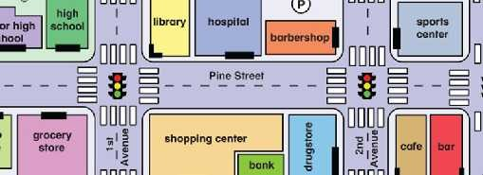
5M

- List any four Debate points to support the topic given below
“Plastic covers should be banned by the Government”. 5M

- With the help of the hints given below, describe a family function you have attended. 5M
An important Occasion-meeting friends and relatives- great joy-decoration- putting
on one’s best clothes- dance-

- Plan a role-play between a Principal and a Parent asking him/her to take care of his
child’s attendance. 5M

*******

